**Wandel-fotozoektocht**

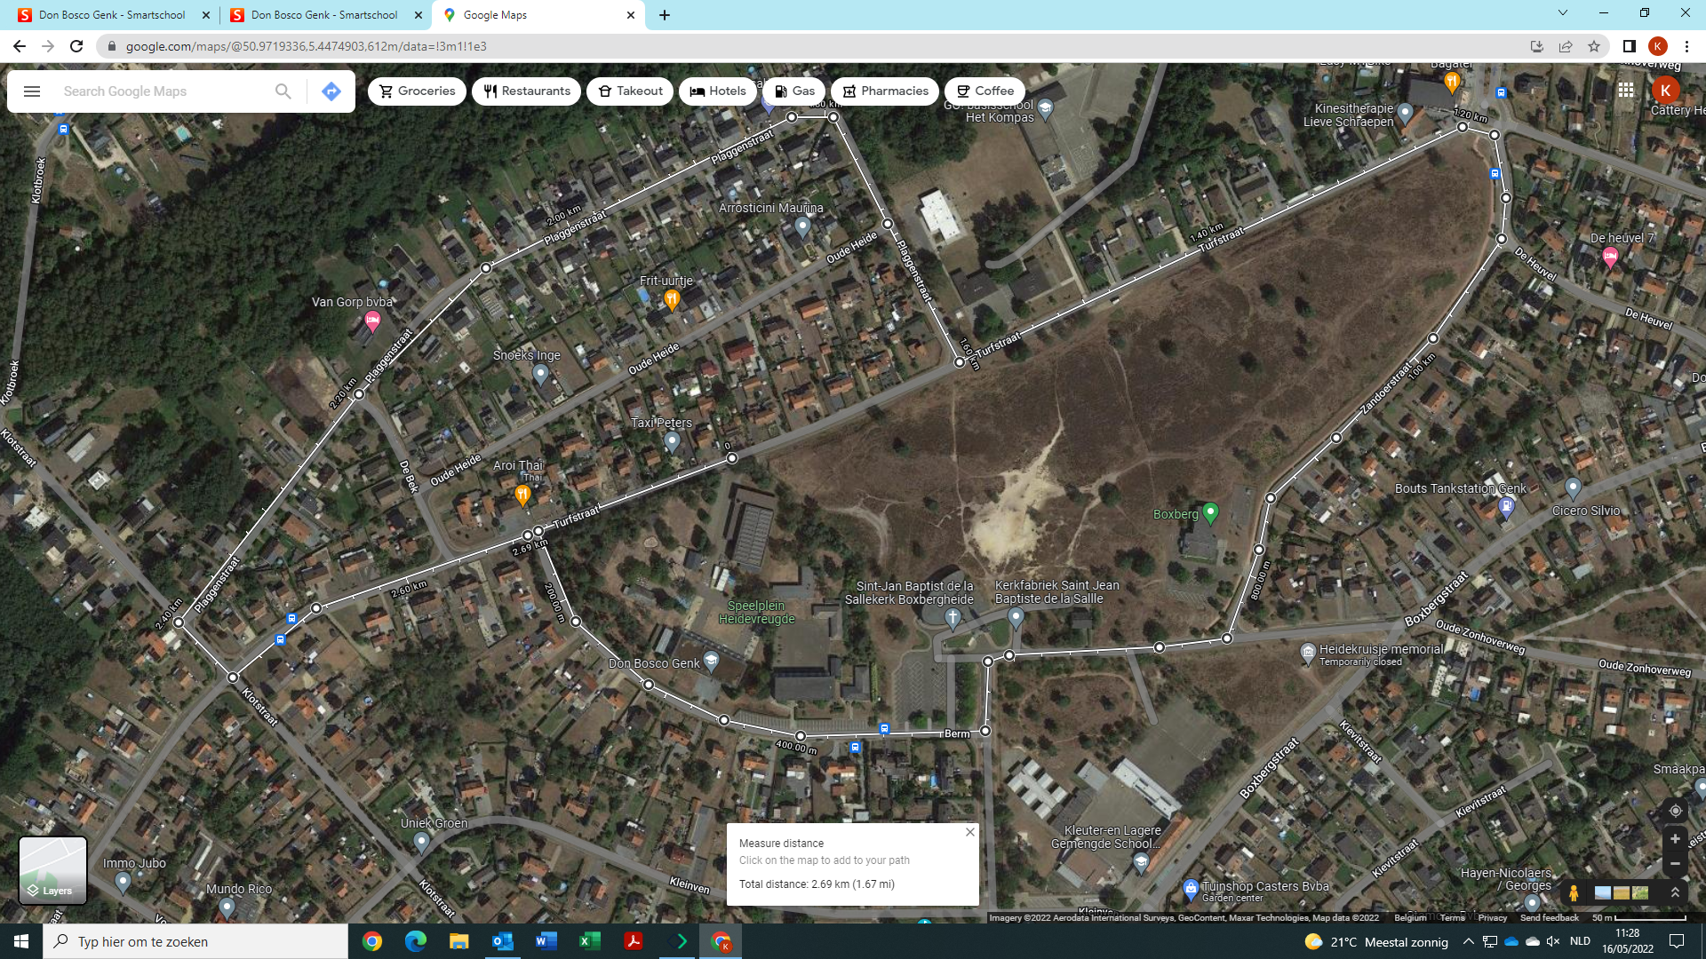

|  |  |  |  |
| --- | --- | --- | --- |
| A | B | C | D |
| E | F | G | H |
| I | J | K | L |
| M |  |  |  |

**Bekijk de foto’s en zet ze in de juiste volgorde.  
Welke foto kom je eerst tegen op onze wandeling?**

|  |  |
| --- | --- |
| **volgorde** | **Letter foto** |
| **1** |  |
| **2** |  |
| **3** |  |
| **4** |  |
| **5** |  |
| **6** |  |
| **7** |  |
| **8** |  |
| **9** |  |
| **10** |  |
| **11** |  |
| **12** |  |
| **13** |  |